Application Number | 07/2023/00698/VAR
Address | 14 Liverpool Road  Penwortham  Preston  Lancashire  PR1 0AD
Applicant | Gin Jar Ale LTD

Development | Variation of conditions 9 and 10 of planning permission 07/2019/7949/FUL as varied by 07/2020/00584/VAR to allow for the external seating area to be used until 22:00hrs
Officer Recommendation | Refusal
Date application valid | 06.09.2023
Target Determination Date | 01.11.2023
Extension of Time | 15.11.2023
Location Plan

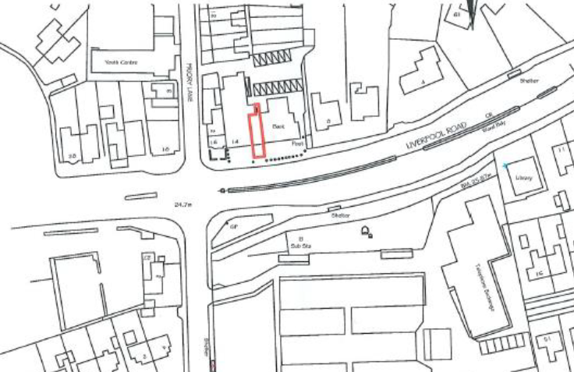

- Report Summary

1.1 The application relates to a drinking establishment known as Gin Jar Ale, located in the district centre of Penwortham. The application seeks a variation of conditions 9 and 10 imposed on the parent permission 07/2019/7949/FUL to allow the use of the outdoor area until 22:00. As originally imposed, the use of the outdoor area was until 18:00. This was varied under permission 07/2020/00584/VAR to allow until 20:00. However, the proposal to further extend the hours of use of the outdoor area would cause loss of amenity to the neighbouring residential properties, particularly the apartments above.

1.2 Although in the district centre, on the main route through Penwortham and opposite the new Tesco supermarket, it is considered that the proposal would create noise and disturbance from patrons using the outdoor area, later into the evening when residents could reasonably expect to enjoy a good level of residential amenity.

- Site and Surrounding Area

2.1 The application relates to the Gin Jar Ale premises at 14 Liverpool Road, Penwortham. It is one of three units formed when the former Booths supermarket was refurbished and sub-divided. The property is close to the crossroads junction of Liverpool Road, Priory Lane and Cop Lane, which is an Air Quality Management Area. The area is predominantly commercial in nature and is within the Penwortham District Centre. Residential apartments are above some of the commercial premises with further residential properties located to the north on Priory Lane. Diagonally opposite is the locally listed Water Tower, a residential property with the Grade II listed Fleece Inn to its west. Both these properties are within the Penwortham Conservation Area.

- Planning History

3.1 There have been a number of planning permissions on the premises when it operated as a supermarket which are not relevant to this current application. The relevant planning history is as follows:

- 07/2018/8006/FUL Conversion to form 3 units. Change of use from A1 (retail) to A3 (restaurant) for 1 unit and 2 units to remain A1 (retail). New shop front, windows, doors and cladding. Approved
- 07/2019/7949/FUL Change of use of Unit 1 from A1 (Retail) to A4 (Drinking Establishment) was conditionally approved.
- 07/2020/00584/VAR for a variation of conditions 9 and 10 to allow for the use of the external seating area until 20:00 hours 07/2021/01194/VAR Variation of condition 14 of planning approval 07/2019/7949/FUL to extend the hours of opening. Approved

- Proposal

4.1 The application proposes a variation of conditions 9 and 10 of planning approval 07/2019/7949/FUL. The wording of the conditions as originally imposed is as follows:

Condition 9
Any outside area to be used by patrons, shall be restricted to the area immediately outside the building facing Liverpool Road. This area shall only be used between the hours of 11:00 hours to 18:00 for the consumption of food and drink.

Condition 10
Table and chairs provided to the outside area shall only be provided between the hours of 11:00 to 18:00. Outside of these hours they must be removed to prevent their unauthorised usage.

4.2 Variation of conditions application 07/2020/00584/VAR varied conditions 9 and 10 to allow the use of the outdoor area until 20:00hrs, effectively extending the time by 2 hours in the evenings.

4.3 The proposal now is to further extend the hours of use by another 2 hours until 22:00 hours.

- Summary of Publicity

5.1 Neighbouring properties were notified with two letters of representation being received.

5.2 One in support of the proposals, commenting as follows:

Gin Jar Ale is an asset to the community of Penwortham. They should be able to open their outside area to the public until 10pm. This should apply to all the bars and restaurants in Penwortham to ensure the restrictions are fair throughout the high street.

5.3 The second was a letter of objection, commenting as follows:

Allowing use of external areas until 10pm has potential to become a noise nuisance to neighbouring residents. If this is passed then neighbouring bars are also likely to apply for extended use of outside areas and before we know it, we could potentially have 5 drinking establishments, within a very concentrated area, with patrons on the roadside creating noise into the late evening.

- Summary of Consultations

6.1 Environmental Health advise that, further to investigations, the premises are in very close proximity to residential properties, in particular the flats above. The current restriction at 20:00 hours preserves the amenity of residents close to the application premises. As evening/night-time progresses, the background sound levels in the area will begin to drop off, which will exacerbate any intrusive patron noise due to use of the external seating area.

6.2 As such Environmental Health’s recommendation is to refuse the application to extend the use of the external seating area, to prevent loss of amenity to residents in the near vicinity.

6.3 County Highways have no objections to the variation of condition 9 to allow for the external seating area to be used until 22:00hrs.

6.4 County Highways commented that they would not be in favour of the variation of condition 10 because the street licence issued includes removing seating/chairs at the close of business.

6.5 However, this was questioned as the premises itself only closes at 23:00 Monday to Friday and Sunday and Midnight on Saturday so it doesn’t appear to conflict with the street licence. County Highways therefore confirmed that, providing the seating/chairs are removed before the premises close, they have no objections to extending the use of the outside area until 22:00 but re-iterate that the premises must comply with the issued street licence.

6.6 Licensing advised that the application conflicts with the current Premises Licence, and therefore the applicant would need to amend their Premises Licence to be in line with their planning condition.

- Material Considerations

7.1 Planning permission was granted in January 2019 for the sub-division of the former Booths supermarket to form 3 units, two A1 retails units and the third an A4 restaurant. Subsequently, planning application 07/2019/7949/FUL sought the change of use of the application property to an A3 drinking establishment. Permission was granted with conditions 9 and 10 being imposed to restrict the hours of use of the external seating area and to ensure that tables and chairs be removed, as follows:

Condition 9
Any outside area to be used by patrons, shall be restricted to the area immediately outside the building facing Liverpool Road. This area shall only be used between the hours of 11:00 hours to 18:00 for the consumption of food and drink.

Condition 10
Table and chairs provided to the outside area shall only be provided between the hours of 11:00 to 18:00. Outside of these hours they must be removed to prevent their unauthorised usage.

7.2 This was then followed by variation of conditions application 07/2020/00584/VAR to vary conditions 9 and 10 to allow the use of the outdoor area until 20:00hrs, effectively extending the time by 2 hours in the evenings. This was approved.

7.3 At the time of consideration of the variation of conditions application 07/2020/00584/VAR, the officer’s committee report advised:

“Environmental Health have no objections to the use of the outside area until 20:00 but would not support 22:00 and providing tables and chairs are removed to prevent unauthorised use after that time.”

7.4 It was further reported:

“Any outside area to be used by patrons shall be restricted to the area immediately outside the building, facing Liverpool Road. This area shall only be used between the hours of 11:00 and 20:00 for the consumption of food and drink (with a view to extending to 22:00 if no complaints are made). However, this wording would result in the condition not being precise and therefore would not pass the tests for imposing conditions. Additionally, Environmental Health would not support an extension until 22:00 and therefore the wording within the brackets would not be included on the amended condition.”

7.5 For this current proposal, and consistent with the advice given for the previous application, Environmental Health advise that the premises are in very close proximity to residential properties, in particular the flats above. The current restriction at 20:00 hours preserves the amenity of residents close to the application premises. As evening/night-time progresses the background sound levels in the area will begin to drop off, which will exacerbate any intrusive patron noise due to use of the external seating area.

7.6 Environmental Health’s recommendation is to refuse the application to extend the use of the external seating area, to prevent loss of amenity to residents in the near vicinity.

7.7 It must also be noted that this application is one of 4 currently pending for the neighbouring drinking establishments and a restaurant to also extend the hours of use of the external area for each premises which would further exacerbate the external use, to the detriment of the amenity of the residential properties above.

7.8 It is also noted that the applicant, within the planning application form ‘would like to vary the hours of use of the outside area to be in line with other similar businesses on Liverpool Road.’ Whilst other drinking establishments along Liverpool Road may have longer hours of use of the external area, all cases are considered on their own merits and the situation on the ground may be very different. In this case there are residential properties and their amenity areas directly above the terrace of commercial properties and therefore cannot be directly compared to other drinking establishments in the vicinity.

- Conclusion

8.1 Whilst the application property is within the Penwortham District Centre which Local Plan Policy E4 seeks to protect and enhance the district centres to maintain their vitality and viability, the impact of the residential amenity of the residential properties at first floor is considered to outweigh the benefits of extending the hours of use of the external area. The proposal is therefore considered to be contrary to policy 17 criteria c) and d) in the Central Lancashire Core Strategy.

- Recommendation

9.1 Refusal.

- Reasons for Refusal

10.1 The proposal to vary conditions 9 and 10 to extend the hours of use of the external area until 22:00 will have a detrimental impact of the residential amenity of the residential properties at first floor contrary to policy 17 criteria c) and d) in the Central Lancashire Core Strategy

11. Relevant Policy

South Ribble Local Plan Policy E4: District Centres

Central Lancashire Core Strategy Policy 17: Design of New Buildings

Penwortham Town Neighbourhood Development Plan

